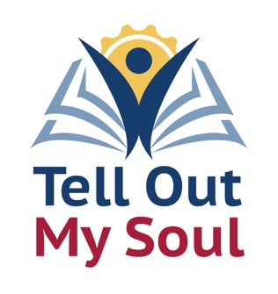

And Mary said,
“My soul magnifies the Lord,
and my spirit rejoices in God my Savior…”
Luke 1:46-47, NRSV

Dear Friends,

Our Stewardship campaign is a chance to reflect on the many ways that we are connected to each other. Our theme this year focuses on the stories we tell and the ways we are called to share our words, our actions, our love, and our joy with the world. This year, with all that has been going on in the news, in our homes, schools and offices, and ever-shifting economic forecasts, the one constant has been the connections we have formed here in our church.

Our stories bring us together. Each of us has a story to tell, a reason why we found this congregation and continue to participate. Each of us has dreams, ambitions, and great ideas, just as each of us has struggles and moments of difficulty. One of the parts of our Good News is that we can bring our whole selves, all our story, to this place and to these people, and receive the support, encouragement, and praise that we need.

We will be hearing so many stories in our campaign this year: artists, musicians, poets, weavers, and more. Each of them focuses on the inspiration they receive from God and how their soul transforms those inspirations into art, music, words, and objects. This same process happens in you as you seek ways to share your gifts from the inspiration and blessing you have been given.

With this letter, I am sending campaign materials for you to use in your discernment for how you will share the Good News of your transformative creativity and abundance with us and with our neighbors. Each hour spent volunteering, each good idea that you have, each dollar that you donate is transformed through prayer and Grace into ministry and mission. We could not be an example of love and compassion in our community without your many and various gifts. Please return your pledge cards by [date] so that we may include them in our ingathering and bless them.

Tell out my soul! The Greatness of the Lord!

